WEEK - 2

TASK 2
- UNAME
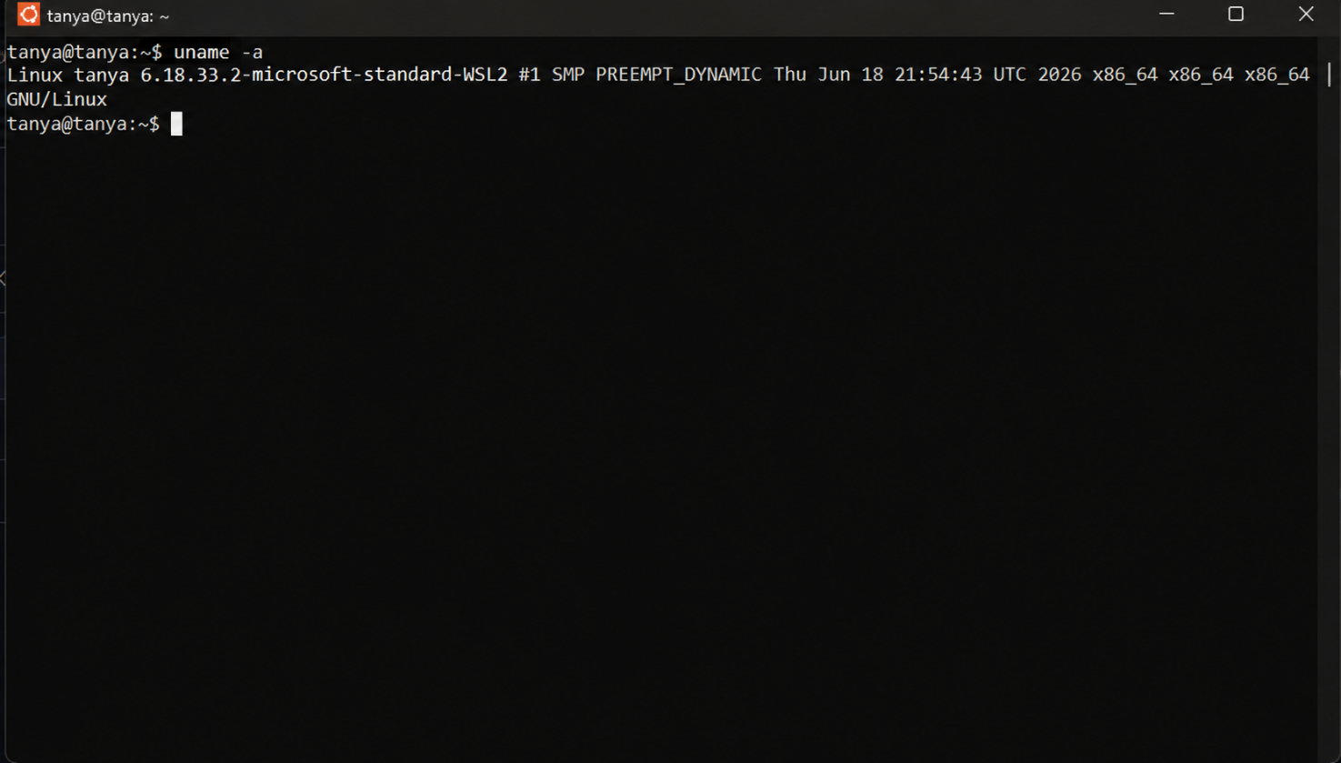

IScpu
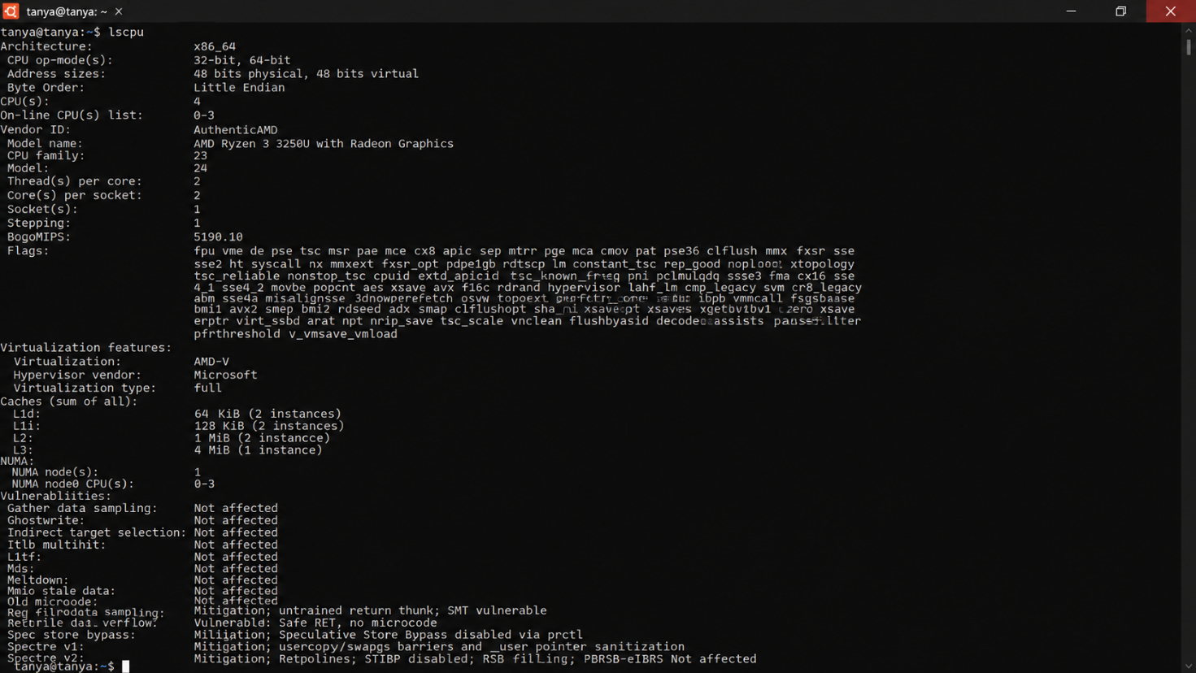

Ps
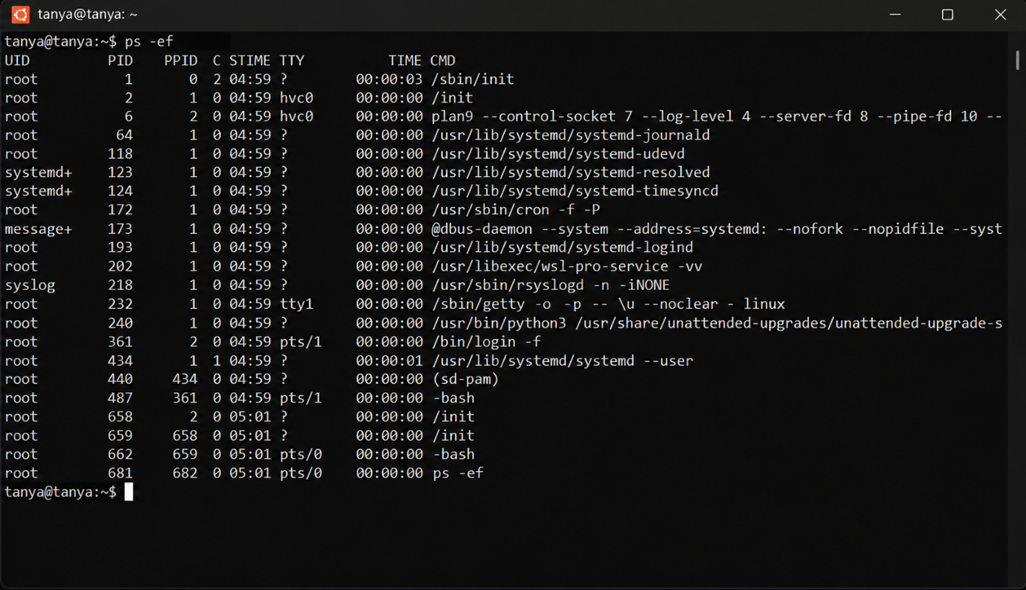

Top
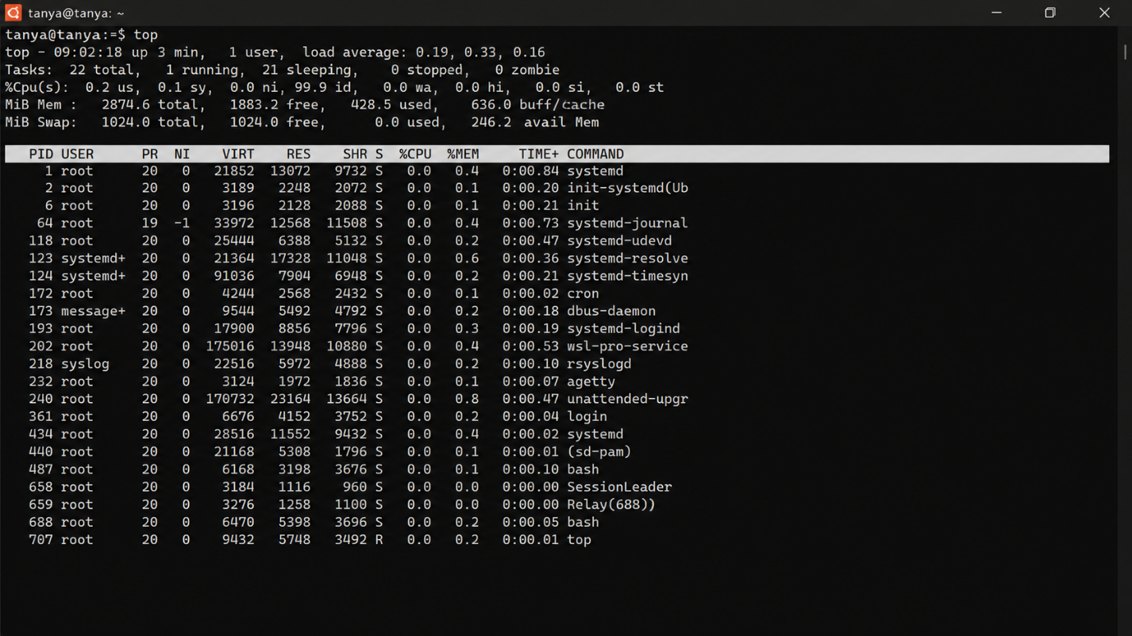

Relationship Between Hardware Resources and OS Services

CPU Abstraction
The CPU executes program instructions. Instead of allowing programs to access the processor directly, the operating system provides process management.

The OS:

    - Creates processes
    - Schedules CPU time
    - Switches between multiple processes
    - Shares CPU fairly among applications

Example:

    - Chrome
    - VS Code
    - Terminal

All appear to run simultaneously because the OS rapidly switches the CPU between them.

Memory Abstraction
The operating system manages RAM through virtual memory. Functions include:
    - Allocating memory to processes
    - Protecting one process from accessing another's memory
    - Reclaiming unused memory
    - Using swap space when RAM becomes full

Applications only see their allocated memory rather than the physical RAM.

Storage Abstraction
Storage devices such as SSDs and HDDs are managed through a file system. The operating system:
    - Creates files and folders

    - Organizes data
    - Reads and writes files
    - Controls access permissions

Users interact with files instead of physical disk sectors.

I/O Device Abstraction
Input/output devices include:
    - Keyboard
    - Mouse
    - Printer
    - USB devices
    - Monitor
    - Network card

The operating system communicates with these devices through device drivers. Applications simply request services like:
    - Read keyboard input
    - Display text
    - Print a document

The OS handles all hardware communication internally.

Role of the Operating System
The operating system acts as an interface between the user and hardware by:

    - Managing CPU scheduling
    - Managing memory allocation
    - Organizing files and storage
    - Controlling input/output devices
    - Providing security and protection
    - Managing multiple processes simultaneously

Observation
Using Linux commands, we observed that:
    - uname provides kernel and operating system information.
    - lscpu displays processor details.

    - ps lists active processes managed by the OS.
    - top shows real-time CPU and memory usage.

These commands demonstrate how the operating system manages hardware resources efficiently while allowing multiple applications to run smoothly.

Conclusion
The Linux operating system abstracts hardware resources by providing high-level services for CPU scheduling, memory management, storage organization, and device communication. This abstraction hides hardware complexity from users and applications, making the system easier to use, secure, and efficient. The commands uname, lscpu, ps, and top help observe how the operating system interacts with and manages the underlying hardware.

